Q1. Change umask value for any user permanently?

Ans. We can do this by adding “ **umask (value)** “ command in the “**.bashrc**” file for that user.

Q2. How can we add a new user without using the adduser / useradd command?

Ans

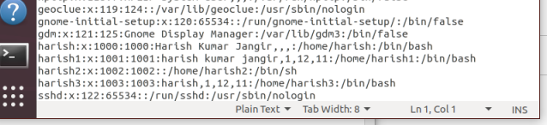To do we have to enter the user info in the **/etc/passwd** file.

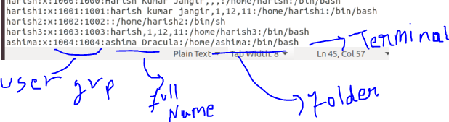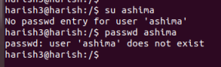 Do the entry.

Now the new user has been added to list. After this we have to clarify the group of the user. TO do so we have to make the user entry in the **/etc/group** file as following.

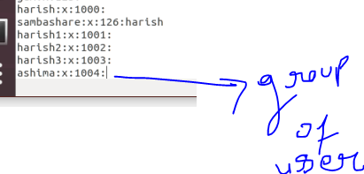

Now go to the /home directory and create a new directory for the user with the user name. And set the password for the new user using “**passwd username”** command.

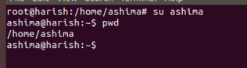Now the user has been added and we can switch to the new user using “**su username”** command

Q3. Can we change the Umask value to 0888. If yes, then how. If no then why?

Ans No we can’t change the Umask value to the 0888 because it’s out of the range of OCTAL number.

Linux uses octal number for permissions

0 : read, write, executable

1 : read, write

2 : read, executable

3 : read

4 : write, executable

5 : write

6 : executable

7 : no permission

Q4. How to add a new user with a unique user id (eg. 1345) & check out the unique id of that user.

Ans

When we create or add a new user using **useradd** command the system will automatically generate a unique user id for that user

But we can also create or add user with the custom user id or say we can specify the user id for a user at the create time for that user.

To do there is an option in useradd command –u which allow us to give the user a custom user id:

Syntax : useradd –u 9885 ahisma2

To check the user id there is a command **id** which display the user id and group id of current user.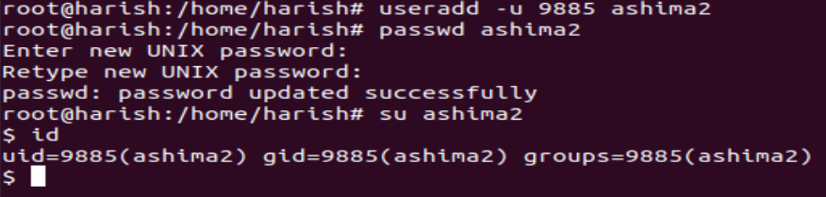

User id and group id also stored in **/etc/passwd** file.

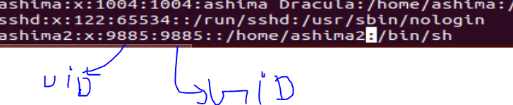

You can also use “ **id <username>** “ to know the uid and gid of user.

Q5. How to change the group of any folder .

5(a). after this checkout the group name of the files present in that folder.

5(b). Try to change the group of the folder and the files present in the same folder using a single command.

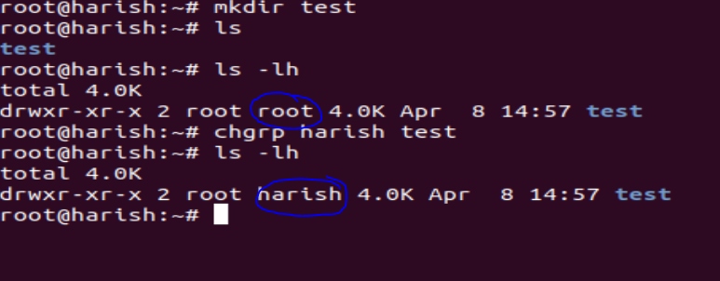Ans to do so we can use chgrp command this command will allow us to change the group of the files and the folder.

